**ASSIGNMENT 3**

**BIT 302**

**Software Engineering**



**Project Proposal**

**Covid Testing Information System (CTIS)**

**Prepared by:**

Team Leader: Pande Putu Rama Pratama Putra (E1700877)

Member: I Nengah Wahyudi Setiawan (E1700868)

Contact Details:

[ramapratama657@gmail.com](mailto:ramapratama657@gmail.com)

nengahwahyudi90[@gmail.com](mailto:sidi.meisanjaya2013@gmail.com)

2021/2022

Contents

Updates on the Analysis / Design Documentation 3

System Sequence Diagram and Contracts 3

Problems faced in Iteration 1 and the solutions 5

Use Case 6

Screen Shots 7

Test Objectives 16

Test Plan 16

Test Cases 16

Unit Testing 16

Integration Testing 36

System Testing 45

Test Analysis Report 60

Conclusion/Review 60

Updated Gant Chart 60

Updates on the Analysis / Design Documentation

System Sequence Diagram and Contracts

1. 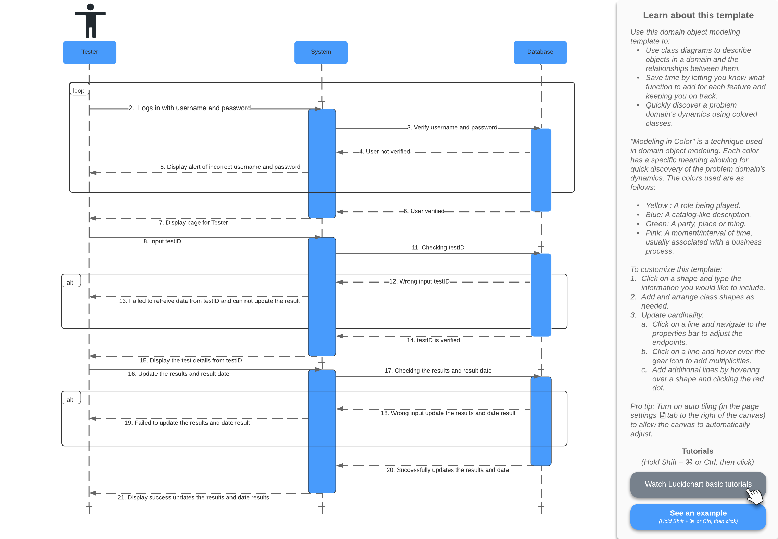Update Test Result

Prepared by: Pande Putu Rama Pratama Putra

|  |  |
| --- | --- |
| **Cross References** | **Update Test Results** |
| **Operation** | Login username and password |
| **Responsible** | To get access page of tester |
| **Pre-conditions** | * The username of user must be available * The password of user must be available |
| **Post-conditions** | * Username are matched according to names in database * Password are matched based on user’s password in database |

|  |  |
| --- | --- |
| **Cross References** | **Update Test Results** |
| **Operation** | Input testID |
| **Responsible** | To get data test from testID |
| **Pre-conditions** | * The testID object must be available |
| **Post-conditions** | * Successfully display test details from testID |

|  |  |
| --- | --- |
| **Cross References** | **Update Test Results** |
| **Operation** | Input date of test and result test |
| **Responsible** | To update the result of the test |
| **Pre-conditions** | * The date of test and result object must be available |
| **Post-conditions** | * Successfully update date of test and result test |

1. View Testing History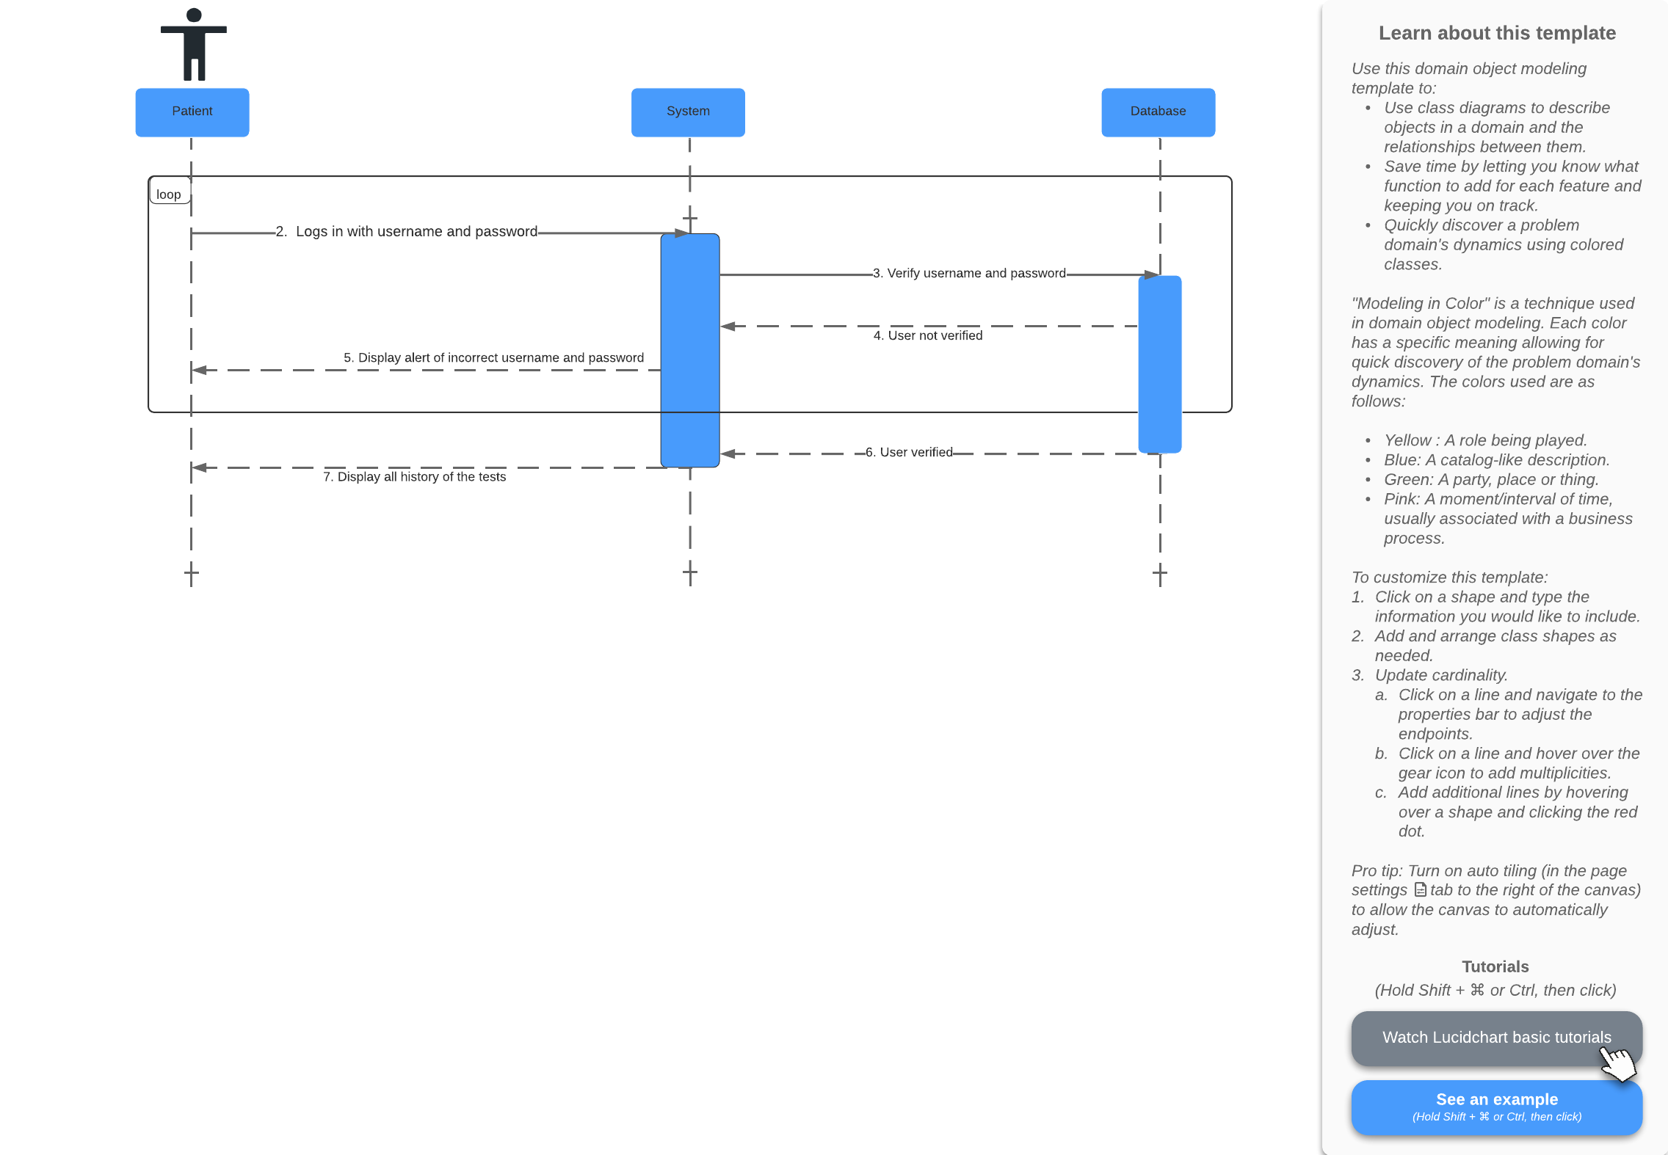

Prepared by: Pande Putu Rama Pratama Putra

|  |  |
| --- | --- |
| **Cross References** | **View Testing History** |
| **Operation** | Login username and password |
| **Responsible** | To display all history of the tests |
| **Pre-conditions** | * The username of user must be available * The password of user must be available |
| **Post-conditions** | * Username are matched according to names in database * Password are matched based on user’s password in database * Successfully displayed all history of the tests |

Problems faced in Iteration 1 and the solutions

In iteration 1 we have not been able to complete all use cases and we can only create a few use cases, namely Login, Logout, Generate Test Report, Register Test Centre, and Record Tester. In iteration 2 we will create and complete use cases that were not created in iteration 1. We also encounter bugs that make user tester cannot login properly. We will fix the bugs in iteration 2 by searching the solution through various resources.

We have a shortage of time to do iteration 1 because there are preparations for the Galungan and Kuningan ceremonies. In iteration 2 we will try to work on this iteration and set the time for the iteration to finish.

We also feel that we lack communication because we are busy with preparations for the Galungan and Kuningan holidays. In iteration 2 we will try to discuss with team member if we find a problem.

Skill is also a problem that we encounter because the skills we have are still lacking in doing iteration 1 and the process to make the iteration 1 takes a longer time. We will try to learn skills from various sources to help us complete iteration 2.

Use Case

|  |  |  |
| --- | --- | --- |
| Use Case | Developed By | Testing |
| Login | Rama | Iteration 1 |
| Log Out | Rama | Iteration 1 |
| Generate Test Report (Test Centre Officer) | Rama | Iteration 1 |
| Register Test Centre (Test Centre Manager) | Wahyudi | Iteration 1 |
| Record Tester (Test Centre Manager) | Wahyudi | Iteration 1 |
| Manage Test Kit Stock (Test Centre Manager) | Wahyudi | Iteration 2 |
| Record New Test (Tester) | Rama | Iteration 2 |
| Update Test Result (Tester) | Rama | Iteration 2 |
| View Testing History (Patient) | Rama | Iteration 2 |

Screen Shots

Login Page

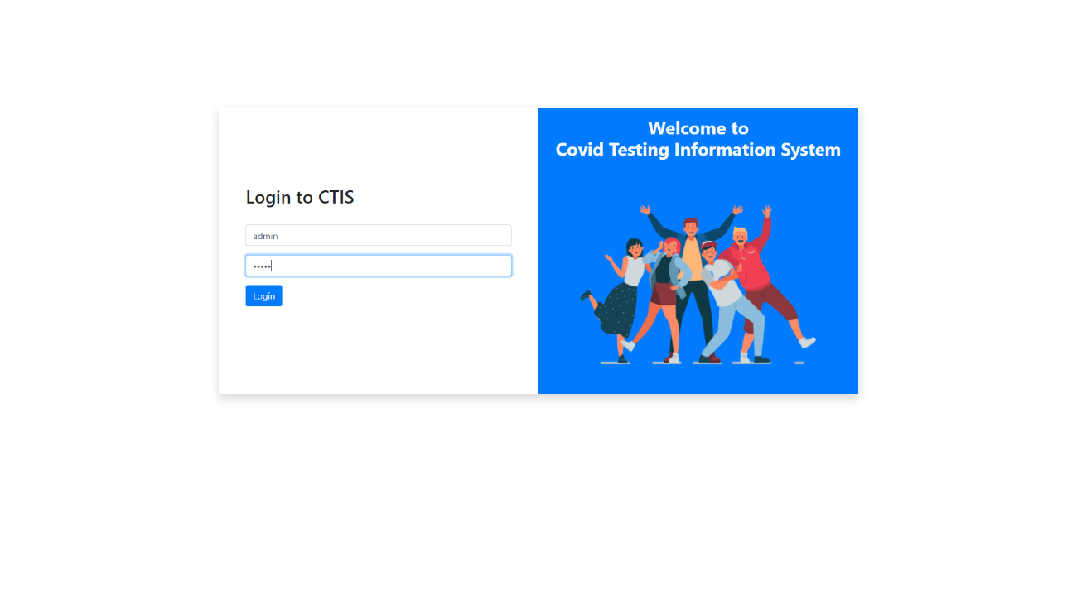

Test Centre Manager Dashboard

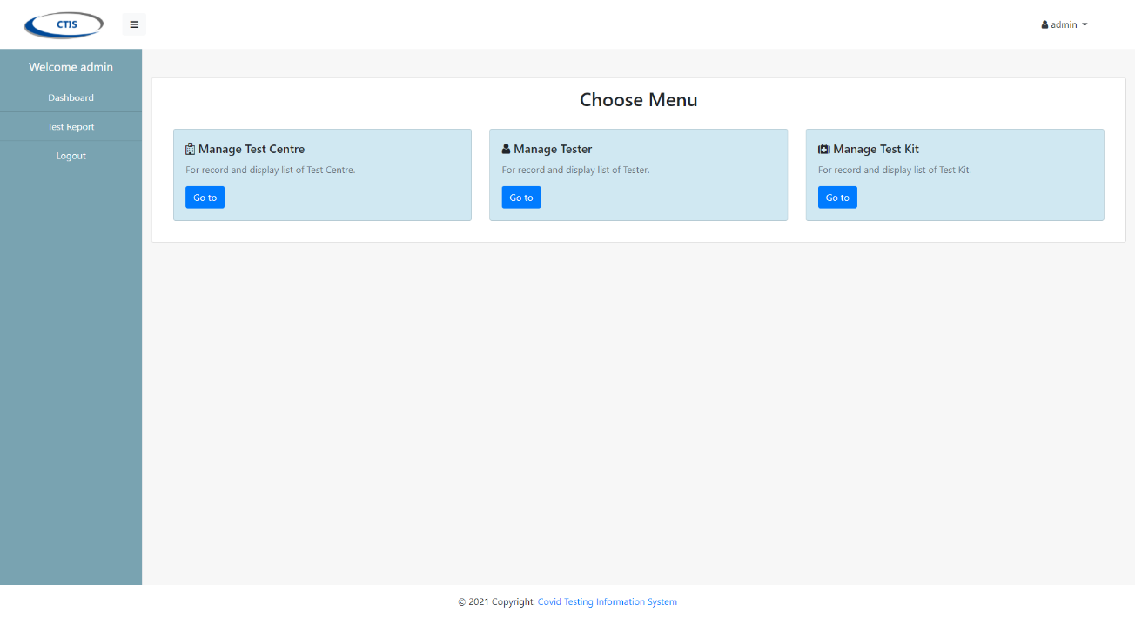

List Test Centre

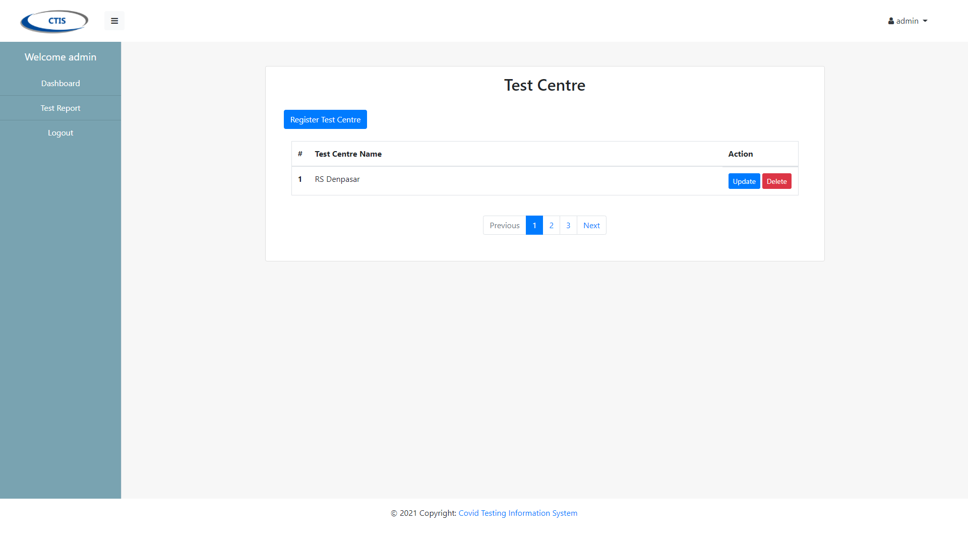

Register Test Centre

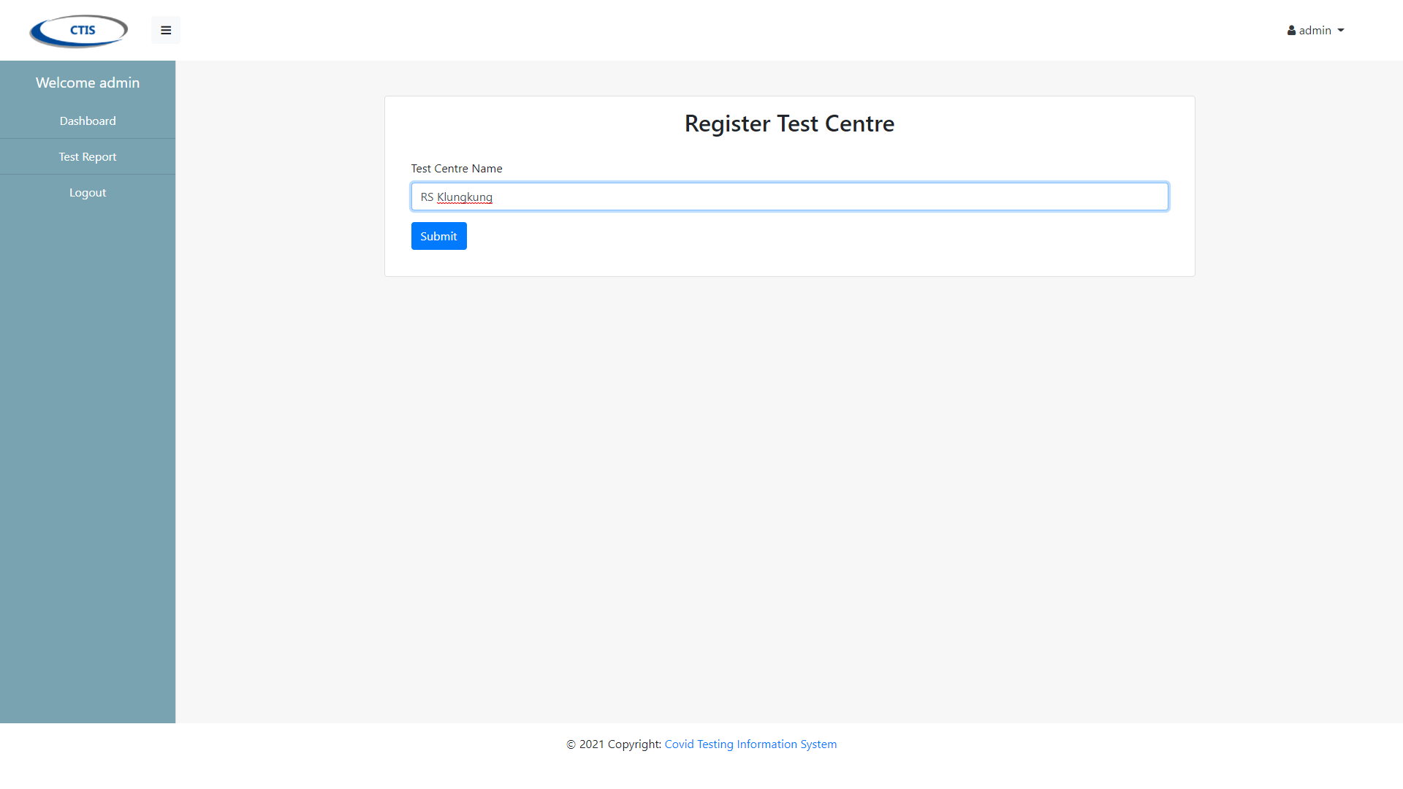

List Tester

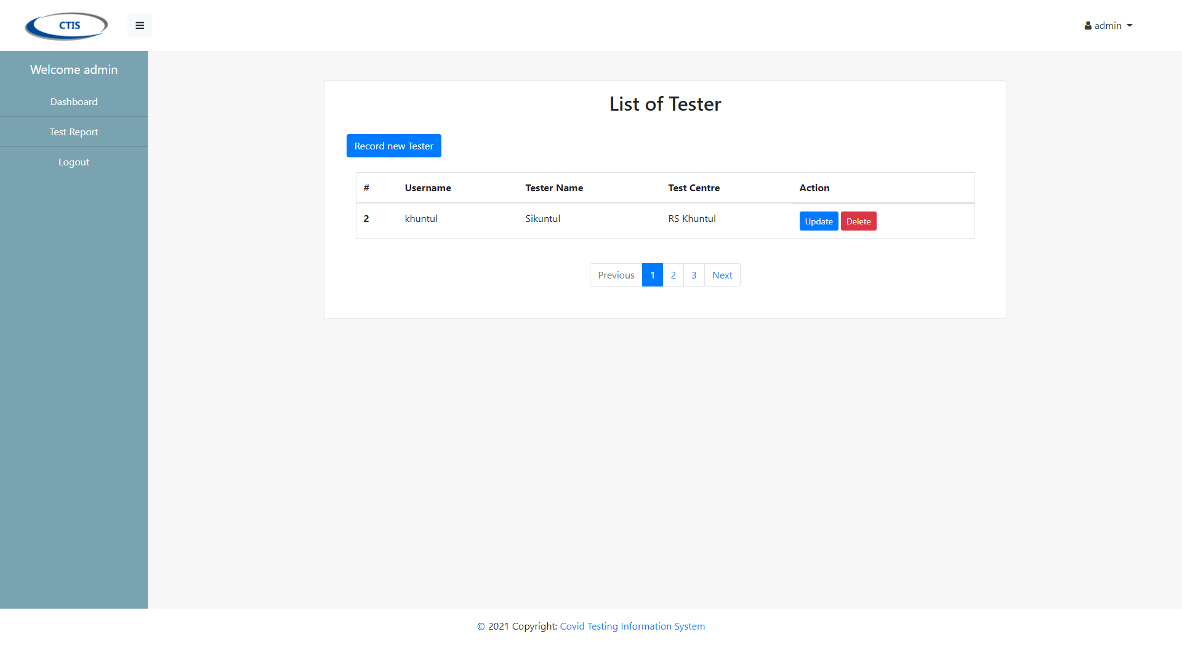

Update Tester

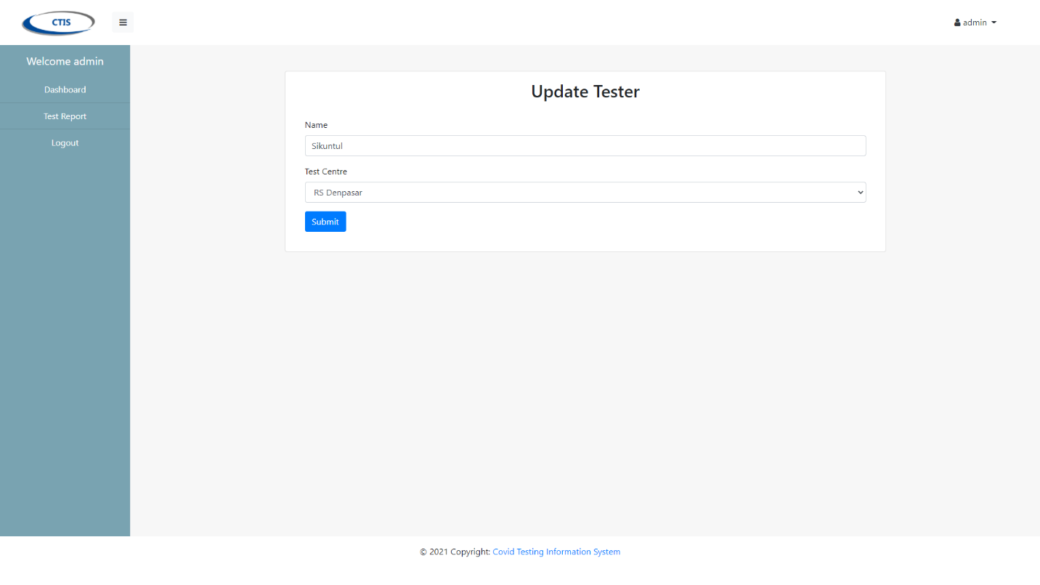

Register Tester

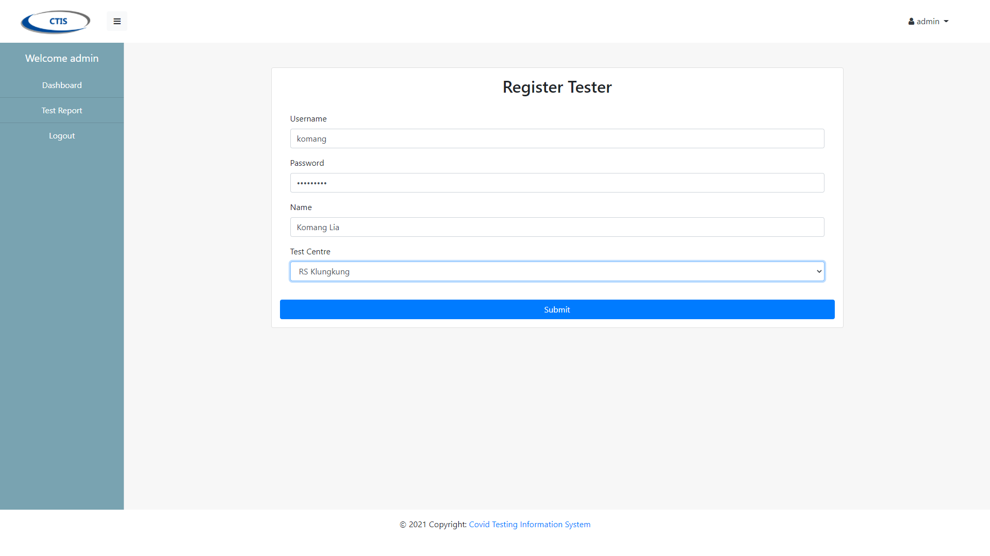

List Test Kit

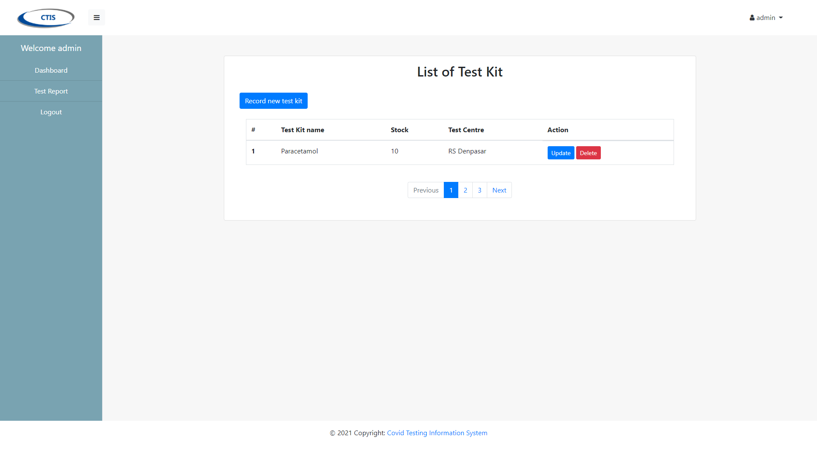

Update Test Kit Stock

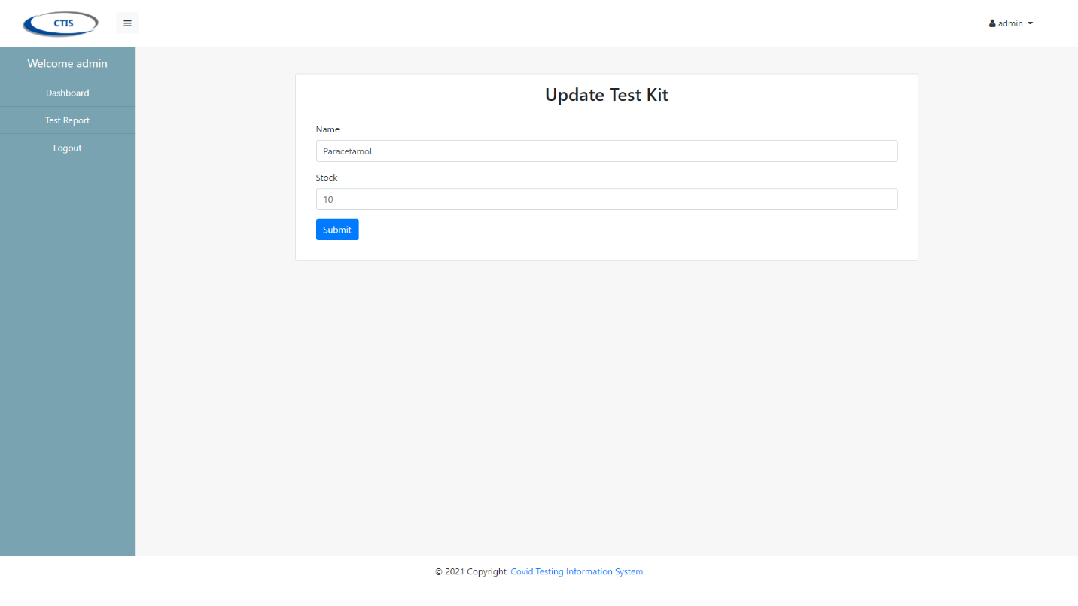

Register Test Kit

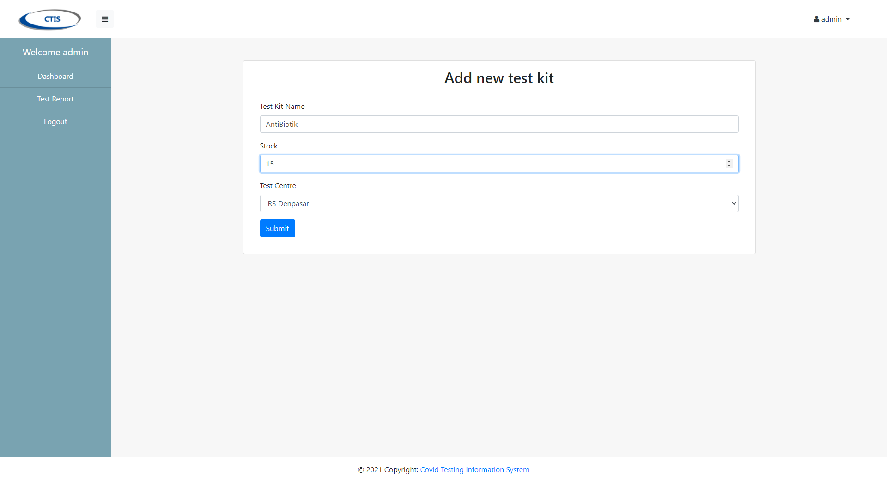

Test Report Page

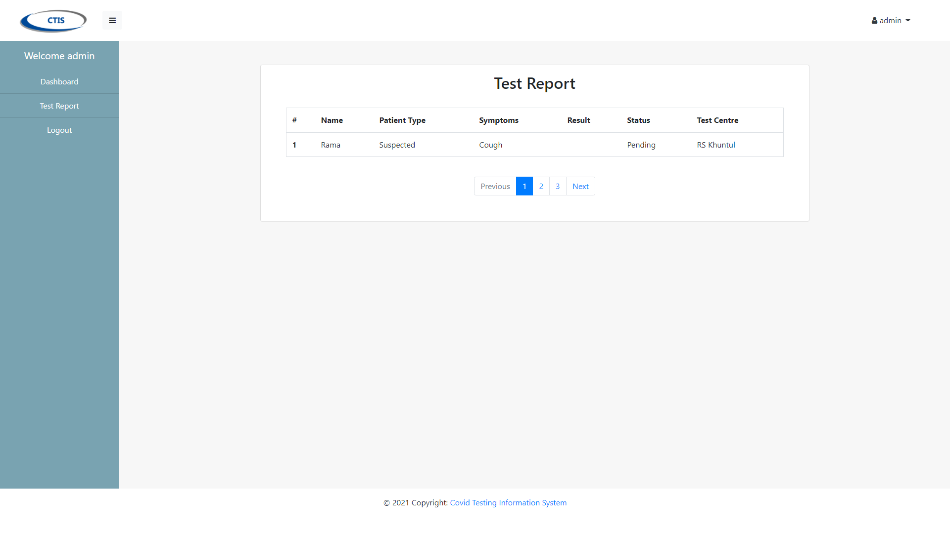

Tester Dashboard

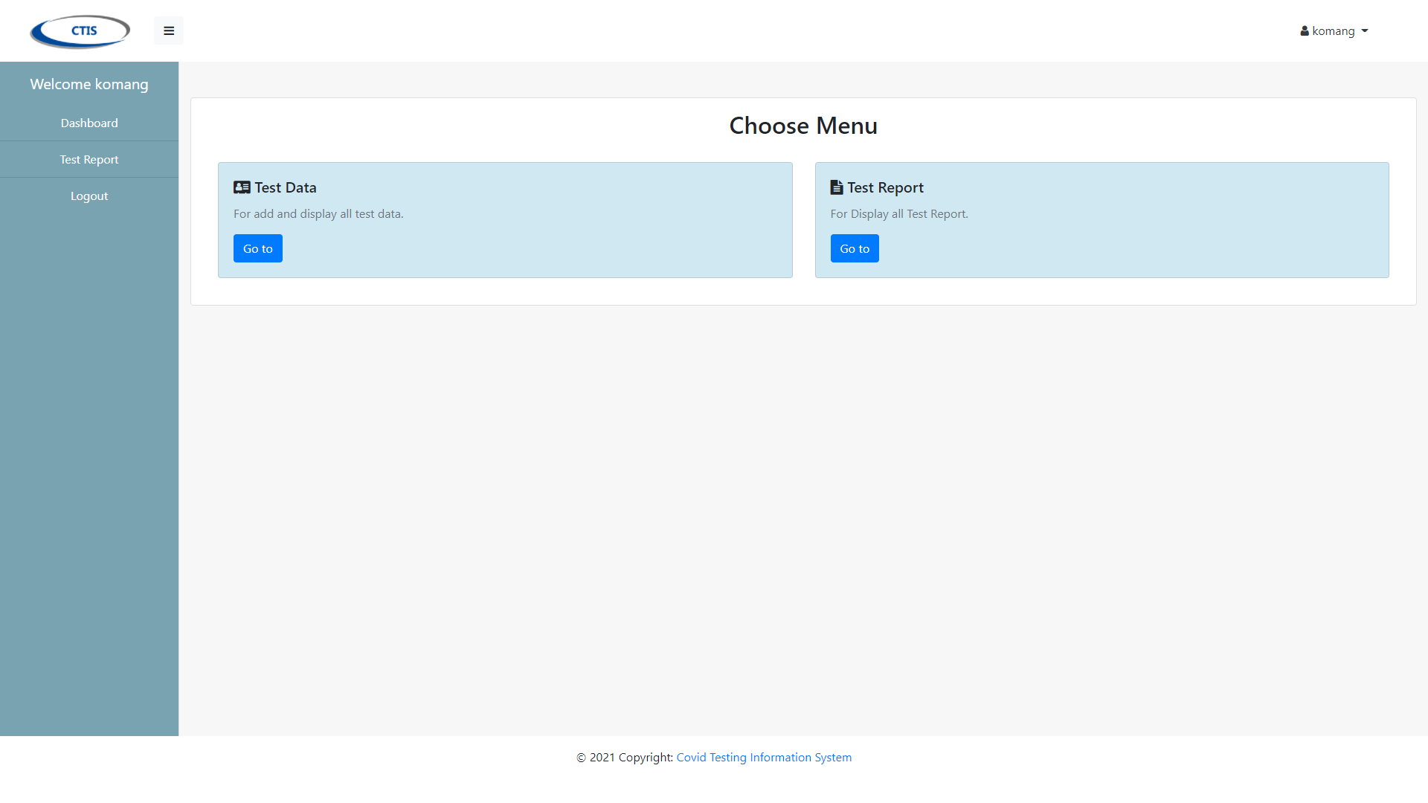

List Test Data

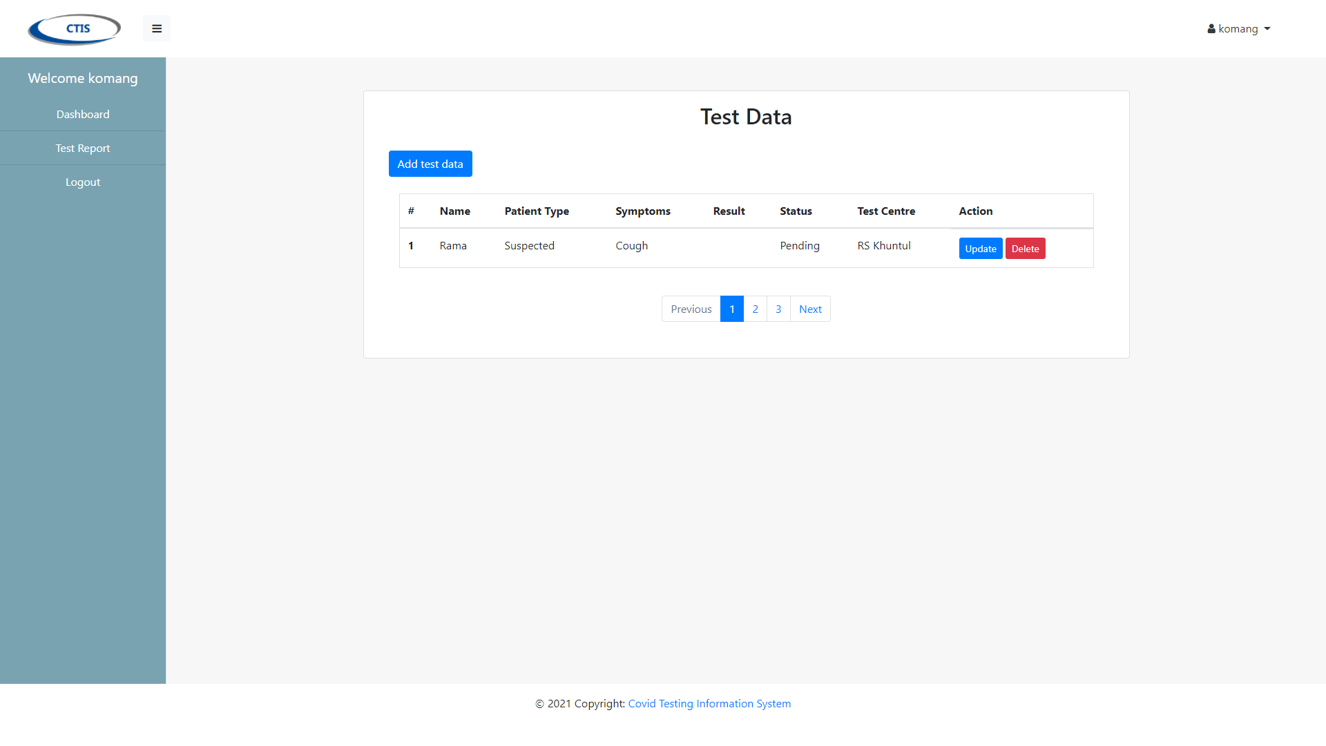

Update Test Data

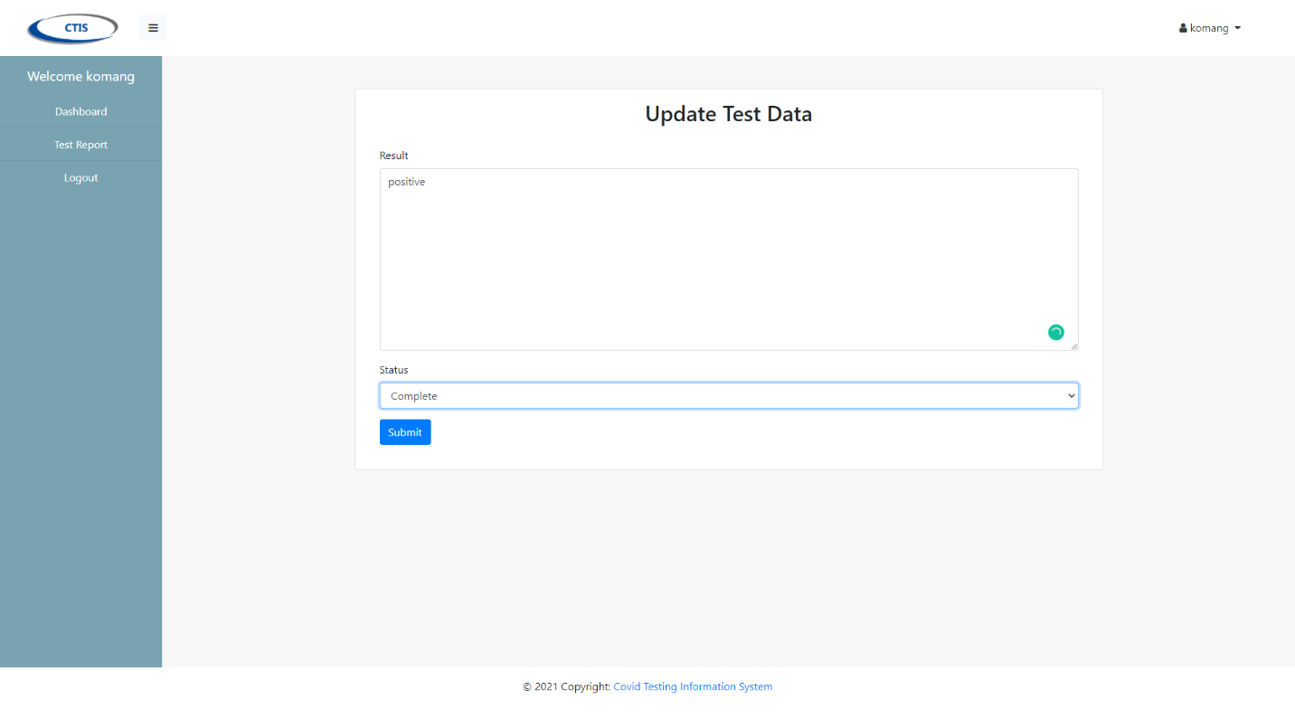

Add Data from Registered Patient

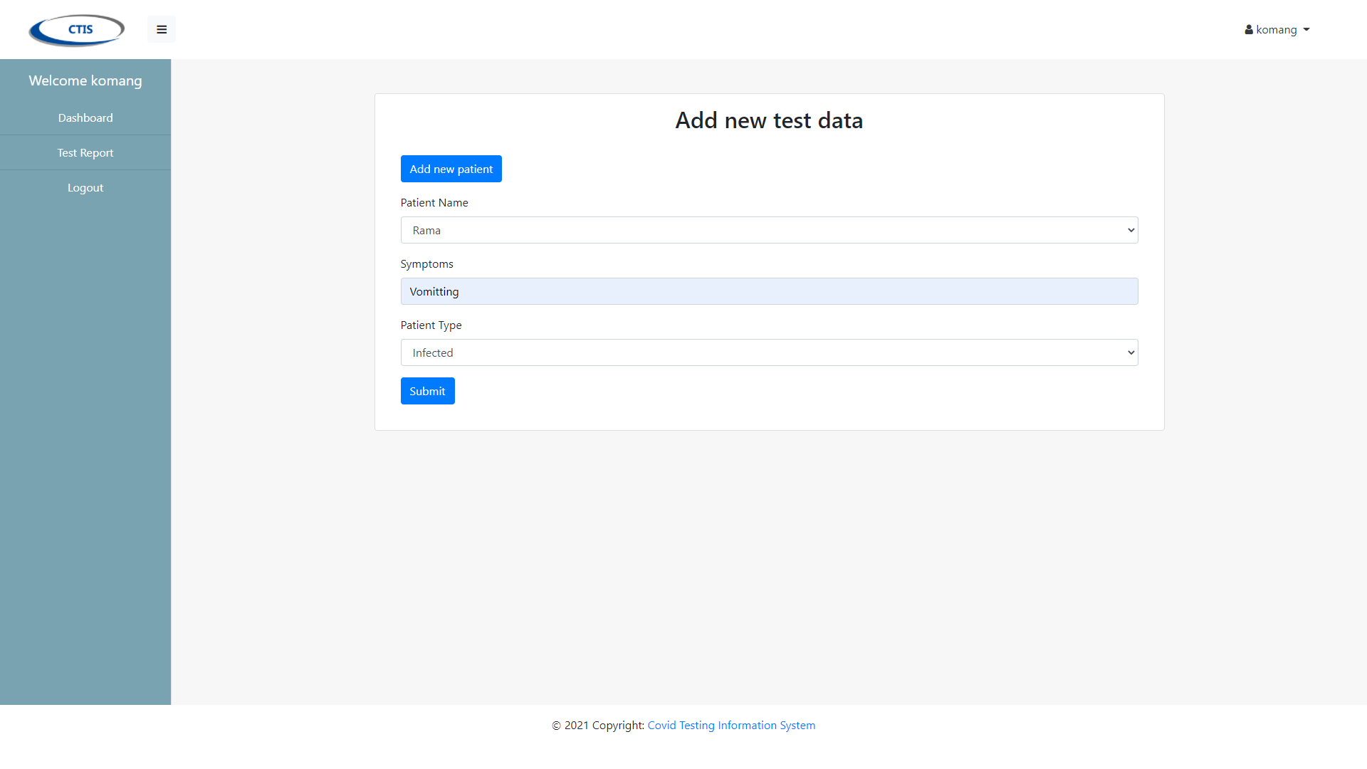

Register New Patient

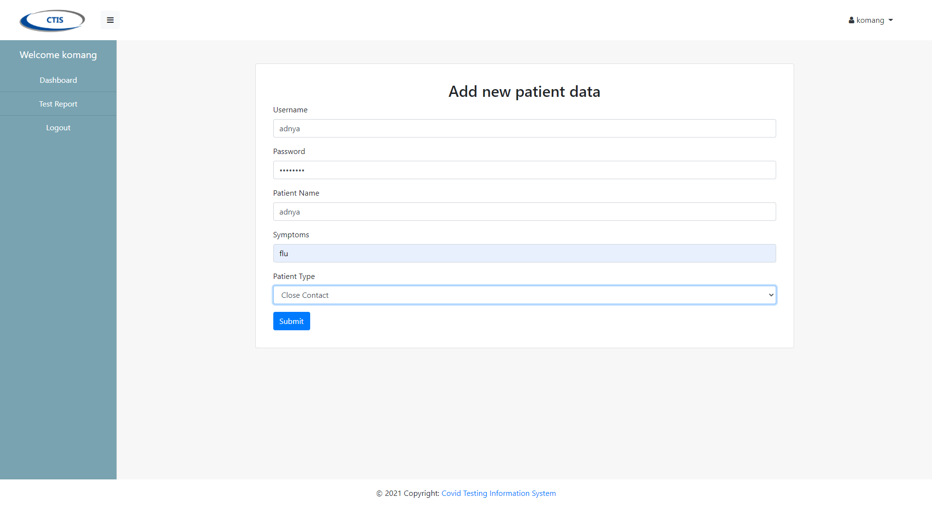

Patient Dashboard

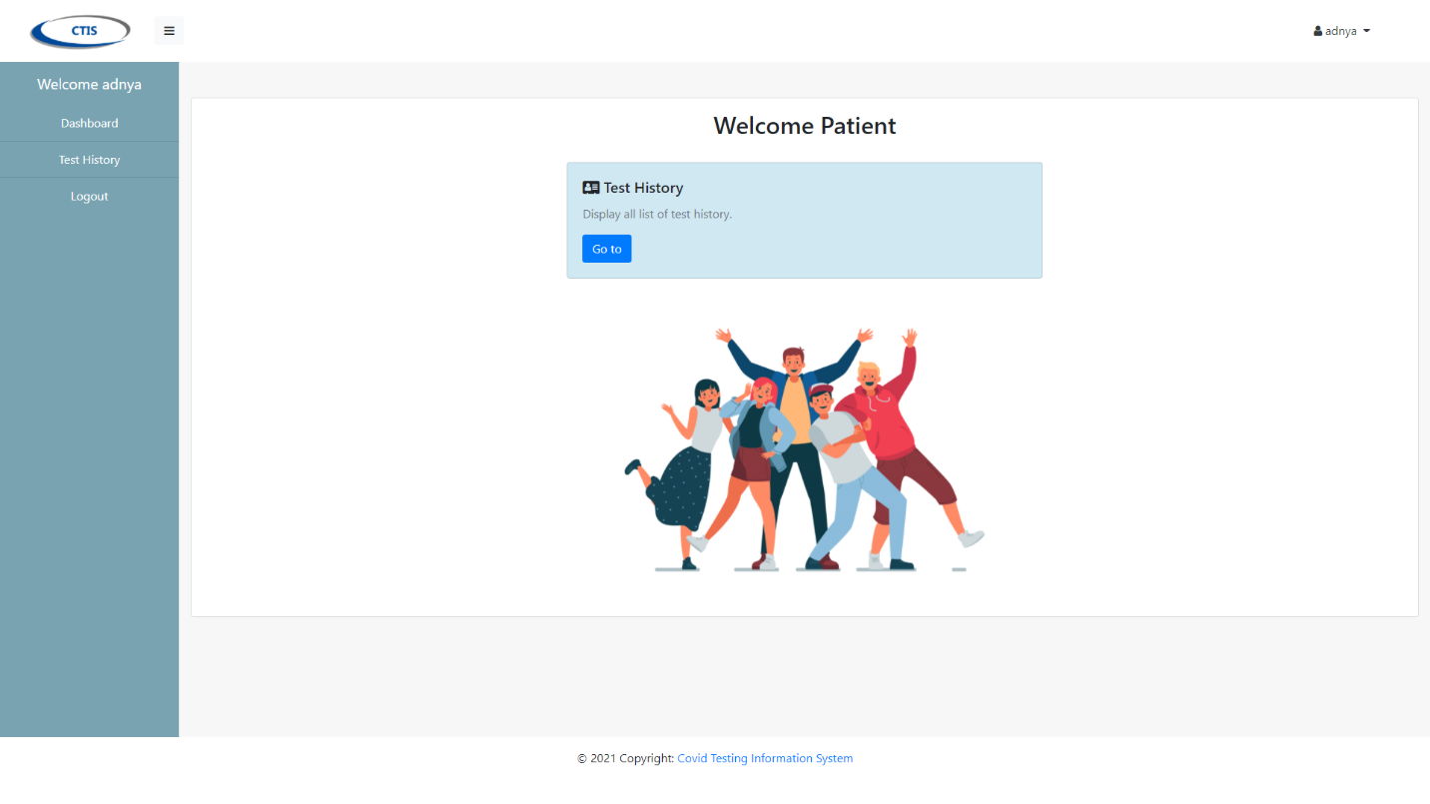

Test History for Patient

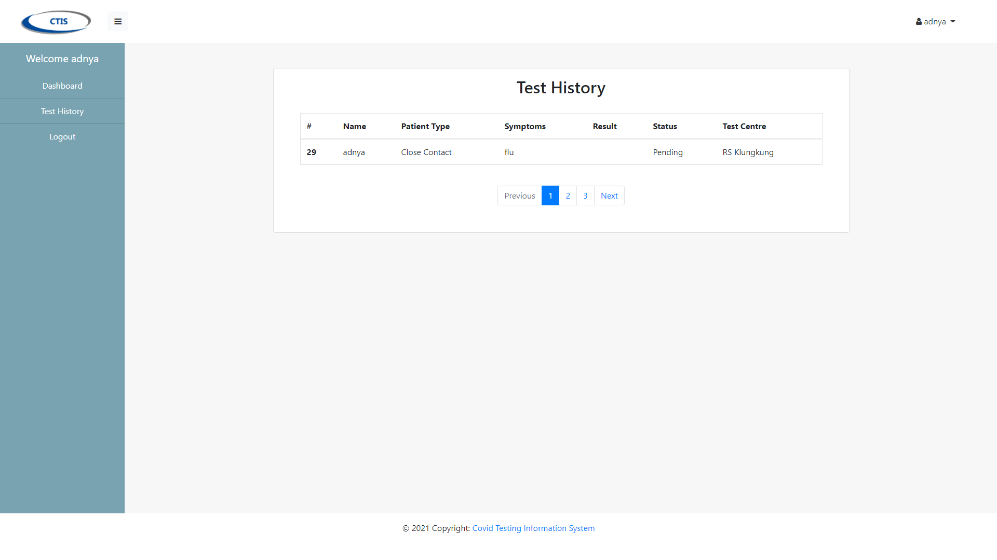

Test Objectives

The objective of testing this system is to find bug and error in the application. With testing, it will build application that be very robust and can run smoothly. Although, we still build-and-testing for make user that can use the application easily and user-friendly. Beside for finding bug and error, the objective of testing is, we can analyze the system and we can put more features for this application.

Our first objective on CTIS system is to make sure the user can login successfully and encrypted with encryption provided by the framework that we use to work. After that, we test the application (the pages) to ensure that working properly. Beside the pages, we also test all the links, button, etc are working properly and directing to the right pages. We test the system according to the role:

* As Test Centre Manager and Tester, user should be able to do basic Create, Read, Update, Delete (CRUD) operation in the system on certain object, like test centre, test kit, test report, etc.
* As Patient, user should be able to view data only to his role and application, like test history.

Test Plan

For the Application System CTIS, we have done testing all the Use Case from Login, Logout, Generate Test Report, Register Test Centre, Record Tester, Manage Test Kit Stock, Record New Test, Update Test Result, and View Testing History. In Iteration 1, we just already test Login, Logout, Generate Test Report, Register Test Centre, and Record Tester only. And we found some bug that user tester cannot login properly. So, we fix it in Iteration while we create another Use Case like Manage Test Kit Stock, Record New Test, Update Test Result, and View Testing. So far, we have tested all the Use Case and it can work properly without bug.

Test Cases

Unit Testing

1. Login

This is login function that user can log in as their positions. And it will direct to their own dashboard page.

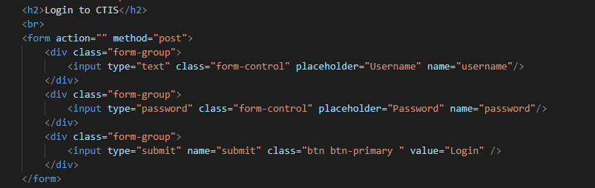

This function is use to validate input from user when log in. If the username and password are not registered or wrong input, it will display message error.

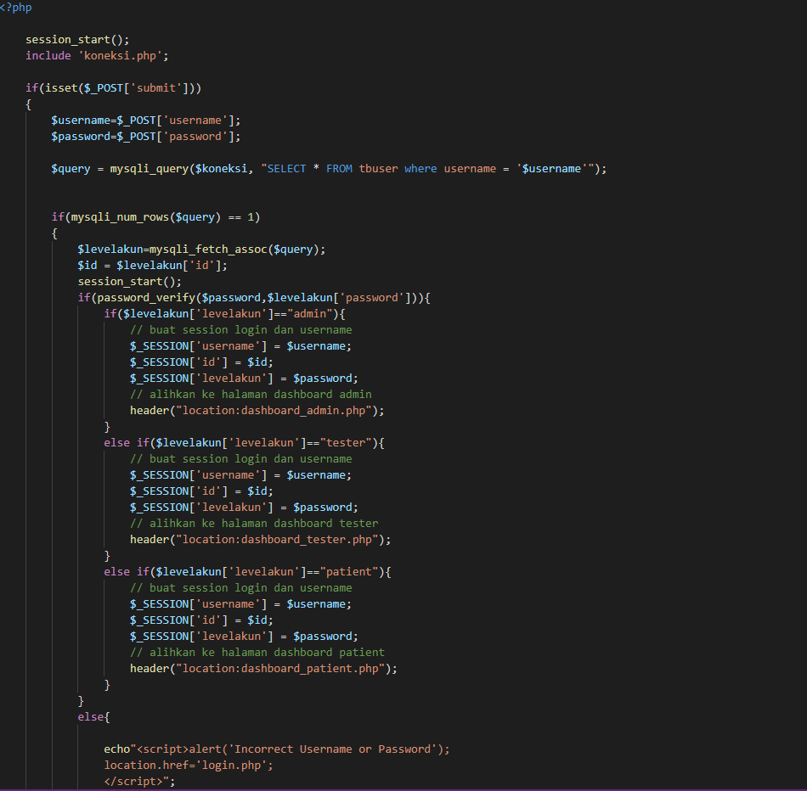

This function is use to connect to database localhost.

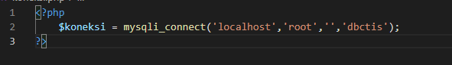

This is Log in Page

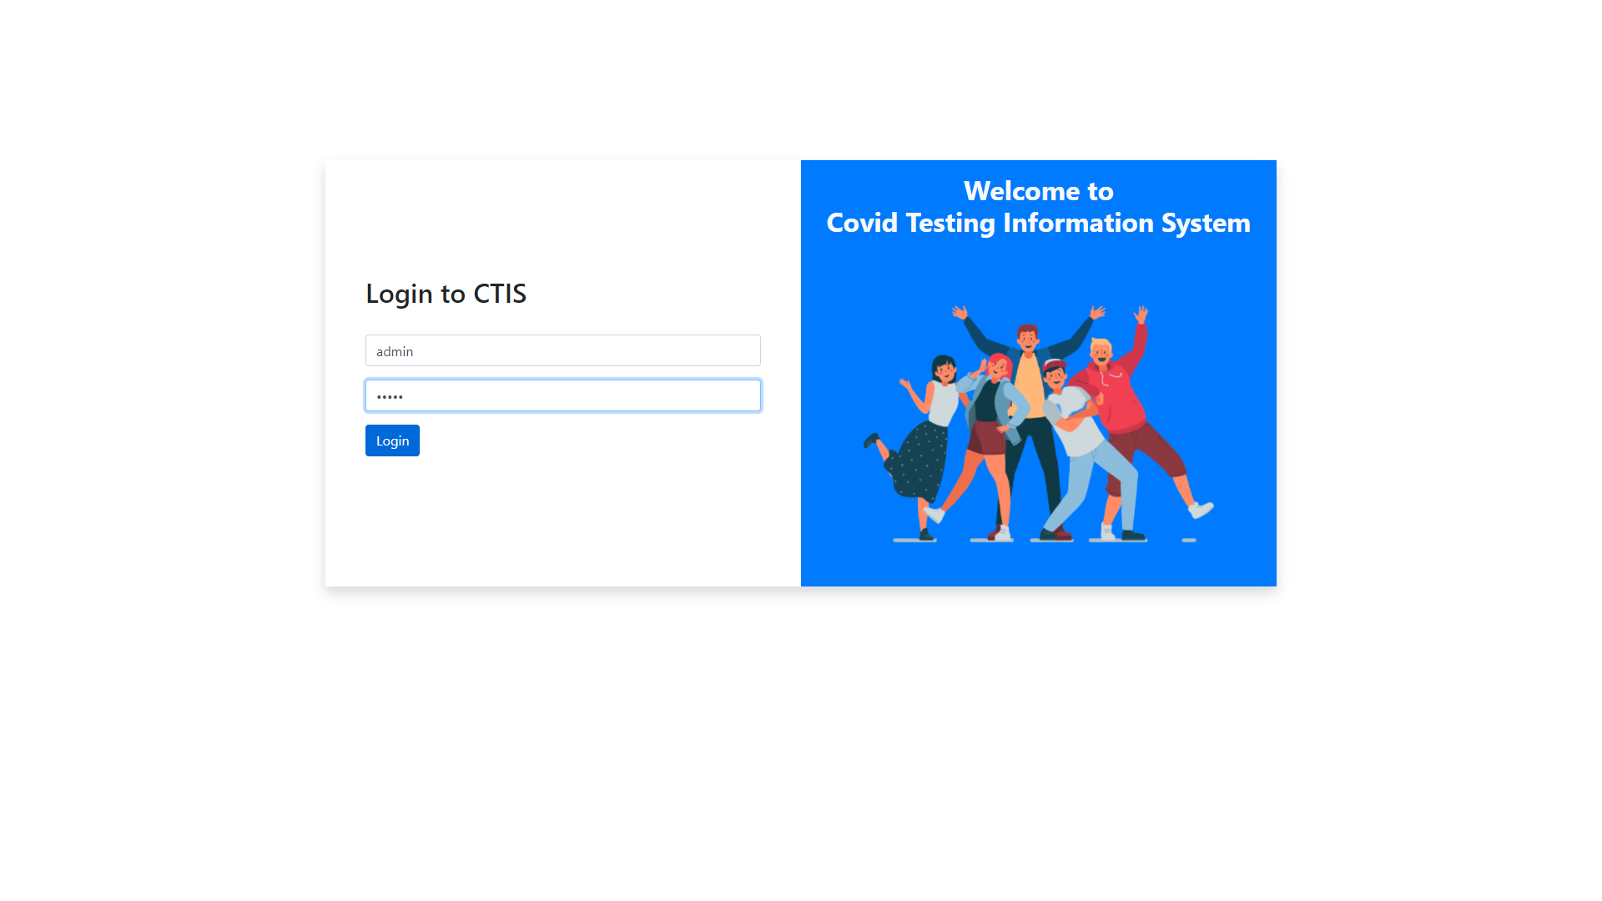

This is Test Centre Manager’s Dashboard

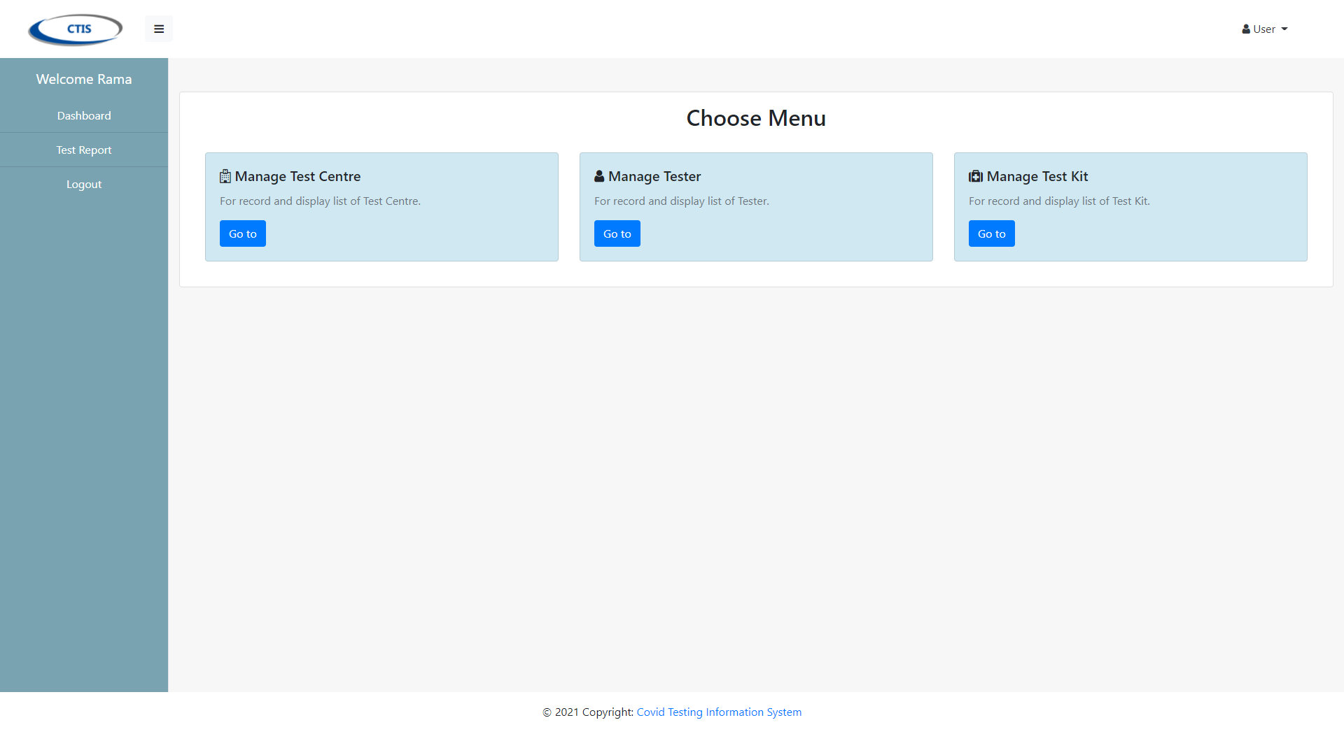

This is Tester’s Dashboard

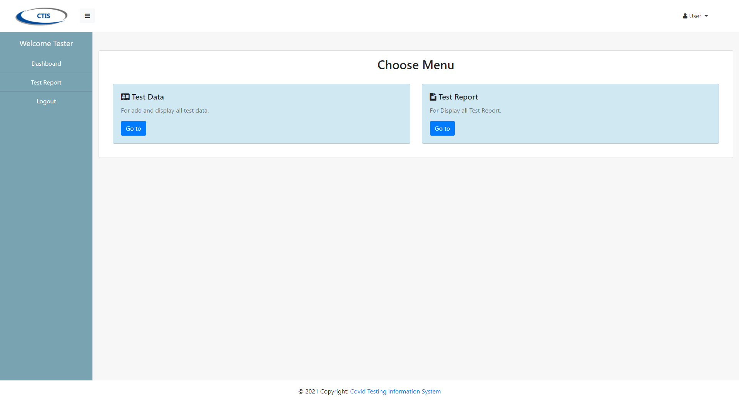

This is Patient’s Dashboard

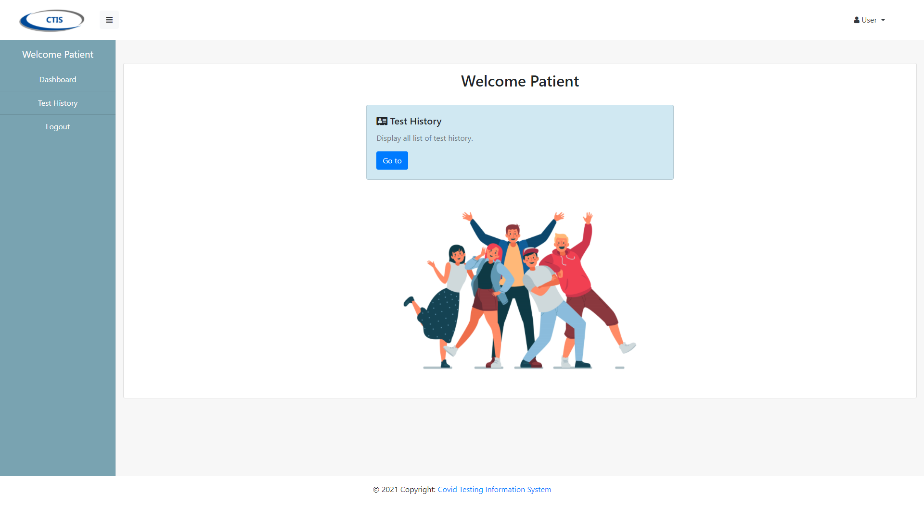

2. Manage Test Centre

This function is to display list all the data of test centre that has been registered.

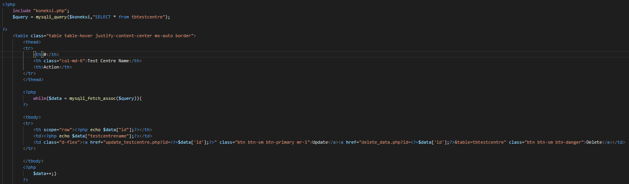

This page displays all the test centre that has been registered.



This function is to registered the test centre from test centre manager.

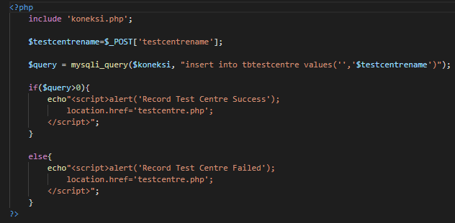

This page is display form registration of test centre.

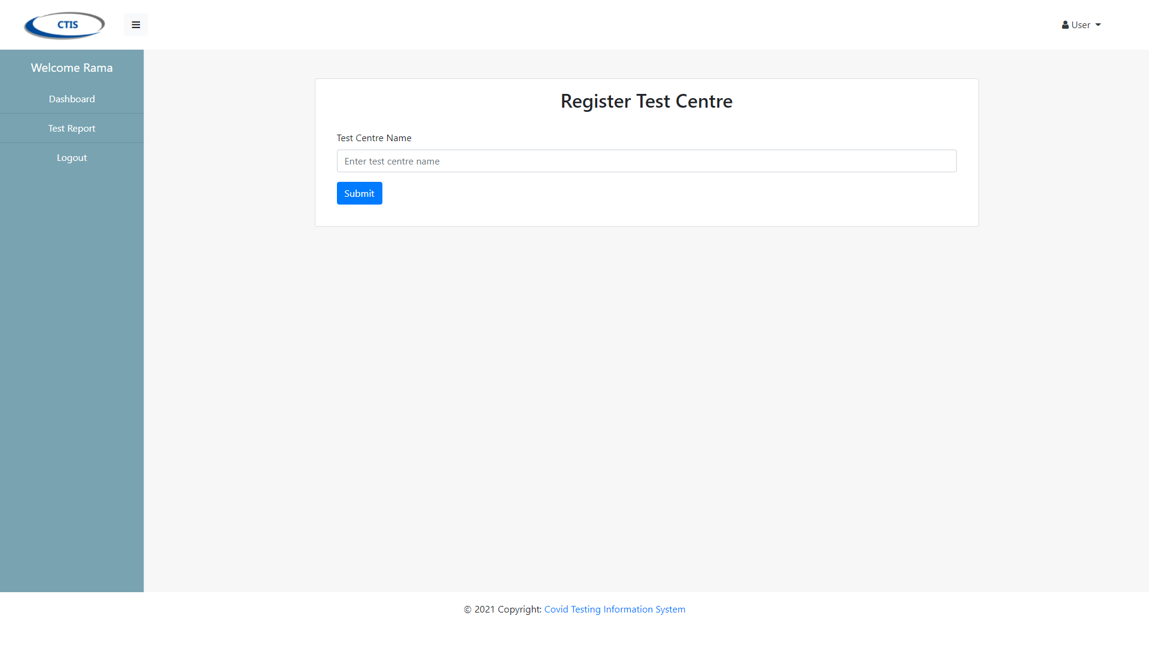

3. Record Tester

This function is use to display all list of tester that has been recorded.

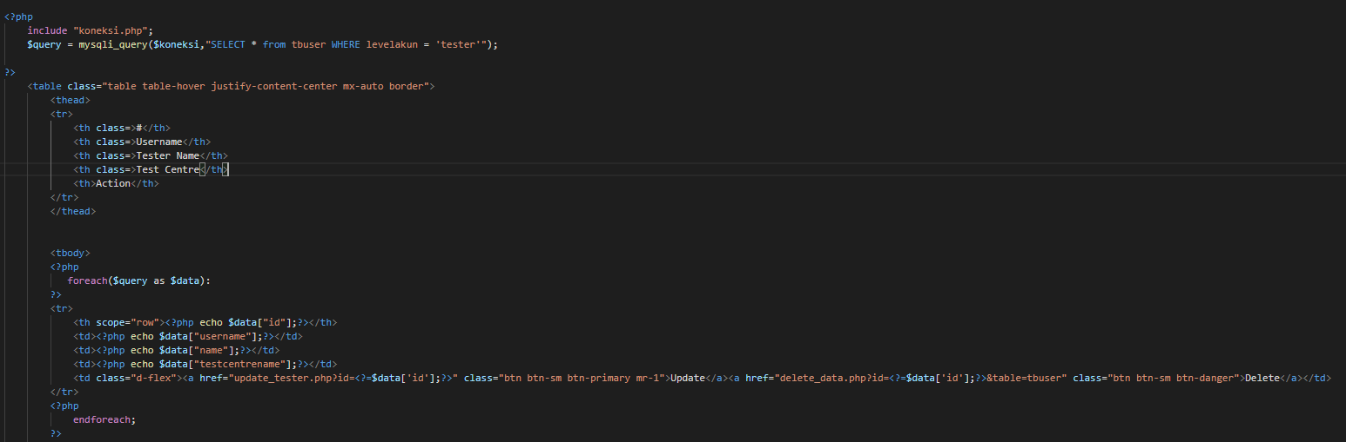

This page displays all the tester that has been recorded.



This function is use to record the new tester from test centre officer.

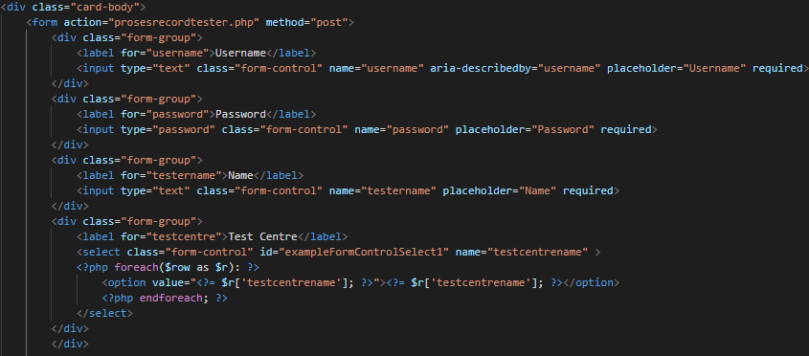

This page displays form record for tester.



This function is use to process the record of new tester.

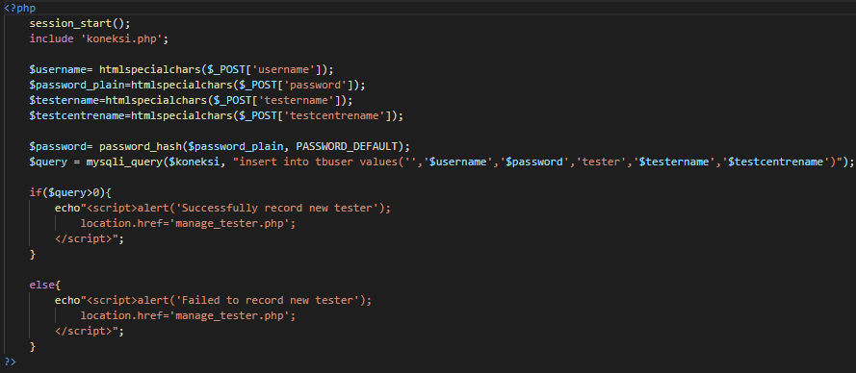

4. Manage Test Kit Stock

This function is use to display all the test kit stock that has been registered or updated.

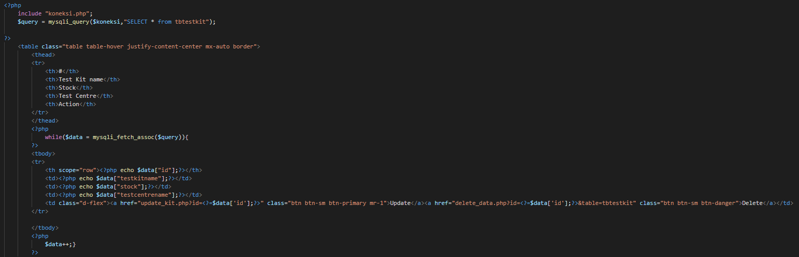

This page displays all the test kit that has been registered.



This function is use to register or update the test kit stock.

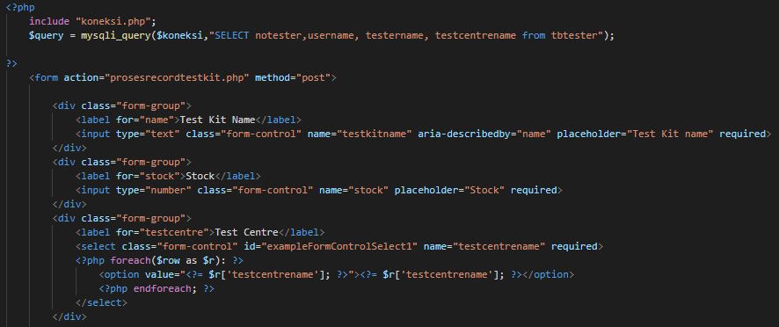

This page is display form of register test kit.

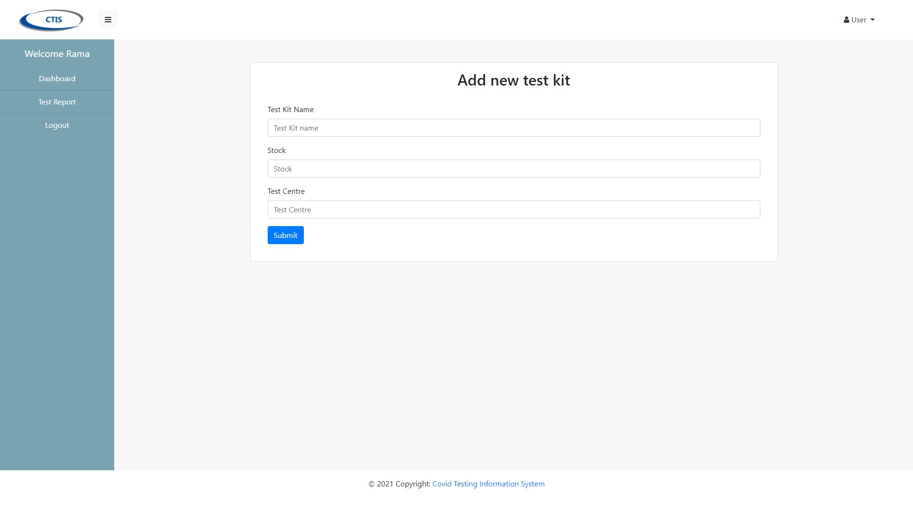

This function is use to process register the test kit

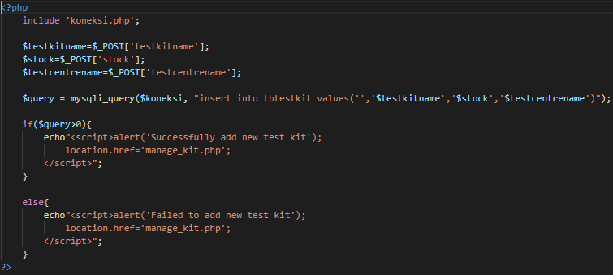

5. Generate Test Report

This function displays all the test that has been registered.

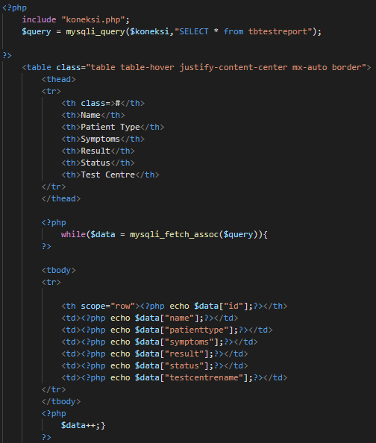

This page is display list all the test report that has been registered.



6. Record New Test

This function is to display list all record test.

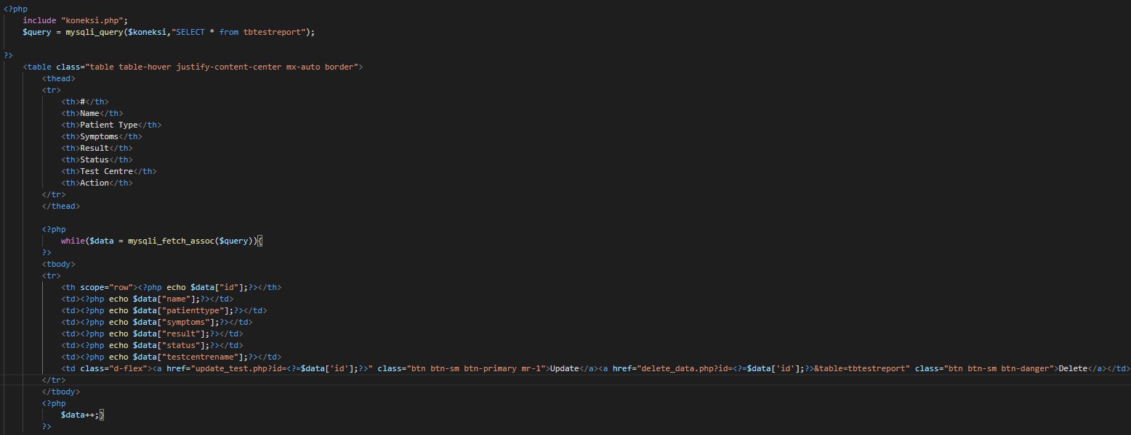

This page is display list all record test



This function is to display form record new test

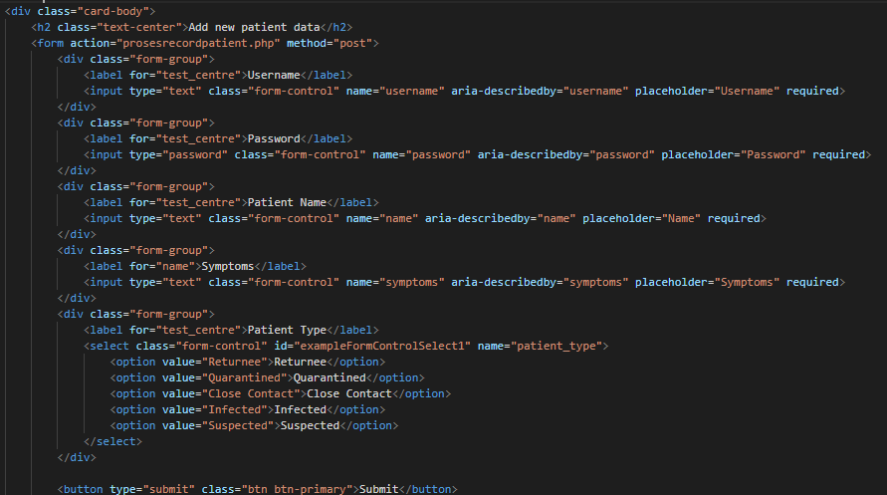

This page is to display form record new test



This function is to process the record new test.

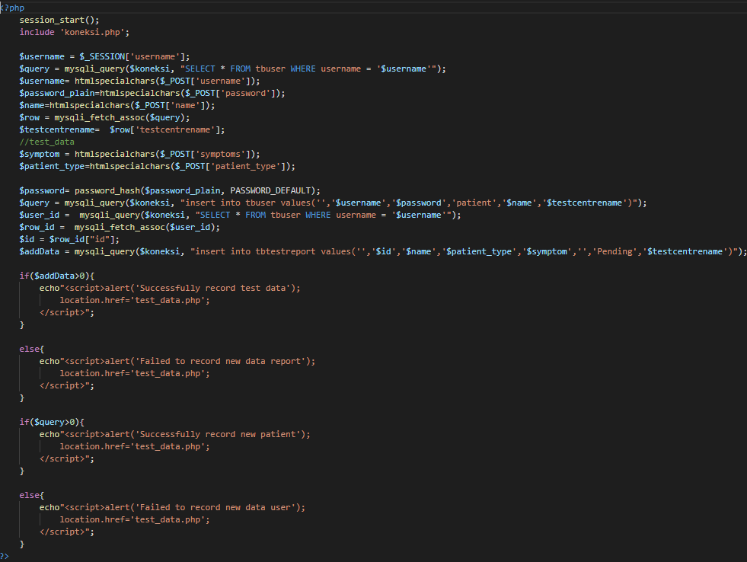

7. Update Test Result

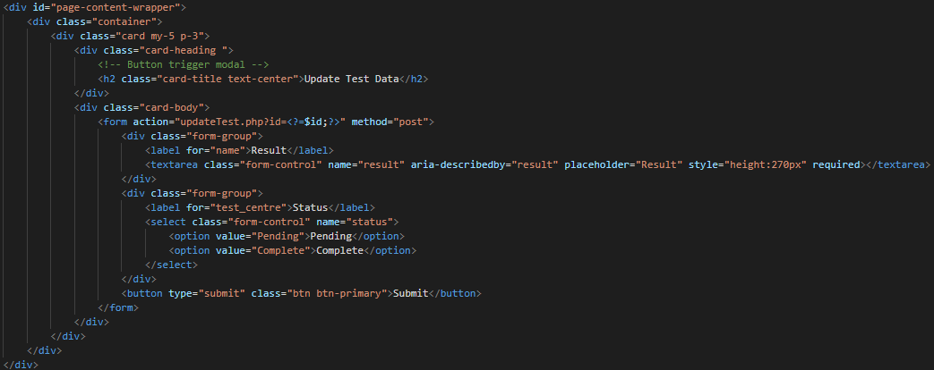This function is to display form update test result.

This page displays form update test result.



This function is to process the update test result

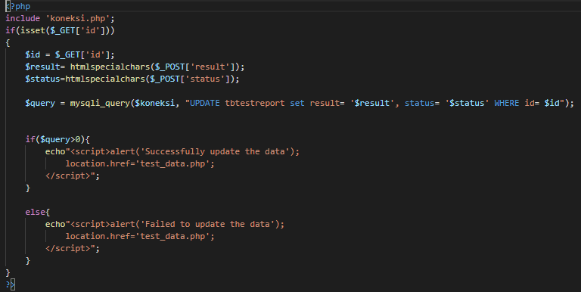

8. View Testing History

This function displays all history data patient.

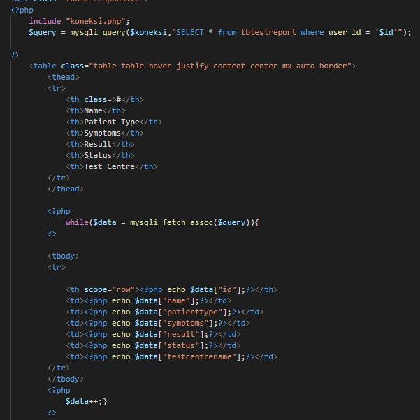

This page is for display all history data patient.



9. Logout

This function is used when the user wants to logout from application.

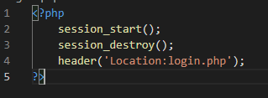

This is page from Test Centre Manager that user want to logout.

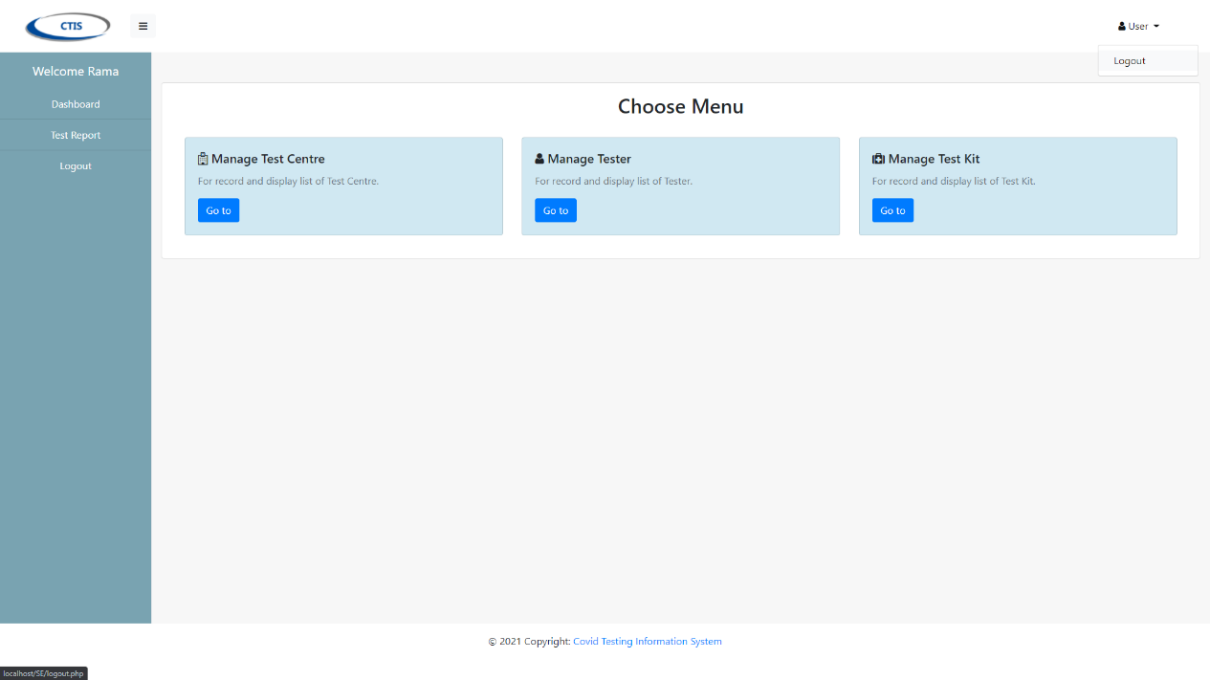

Integration Testing

We are use Selenium Plug-in from Google Chrome for record the system will run based on the functions in each use case.

1. Login & Logout Test Centre Manager

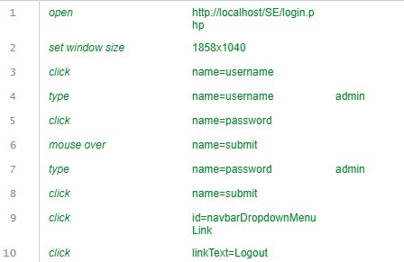

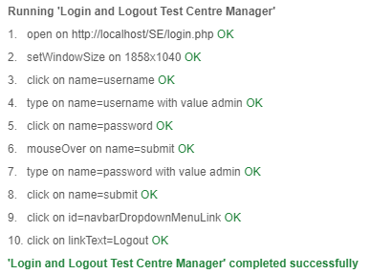

2. Login & Logout Tester

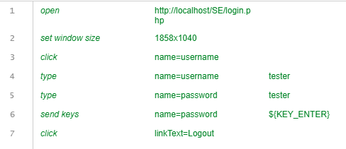

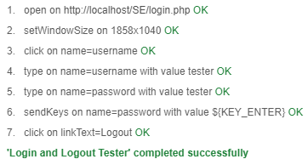

3. Login & Logout Patient

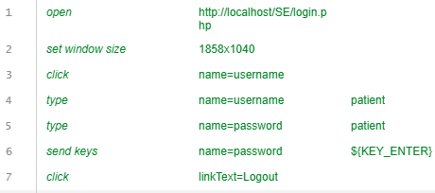

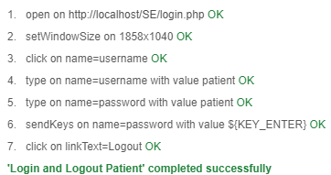

4. Register Test Centre

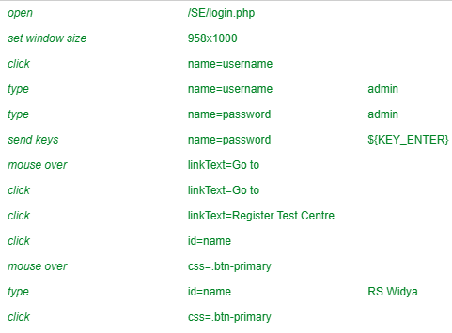

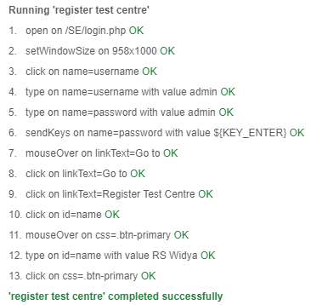

5. Record Tester

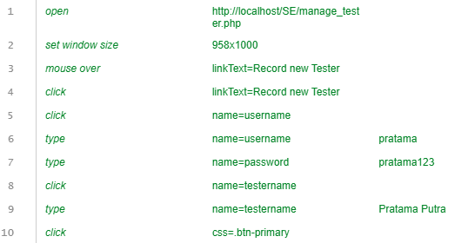

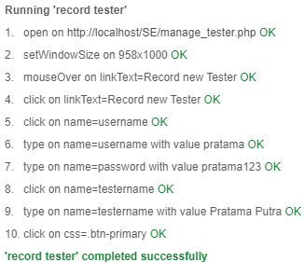

6. Generate Test Report

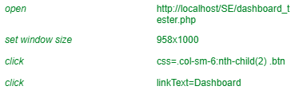

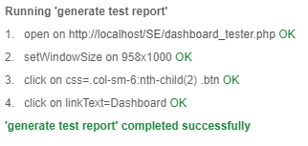

7. Manage Test Kit Stock

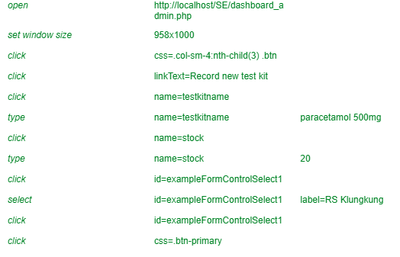

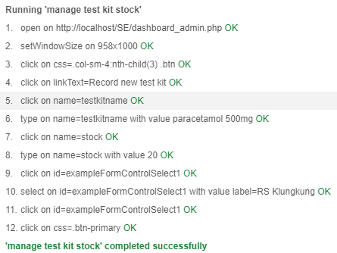

8. Record New Test

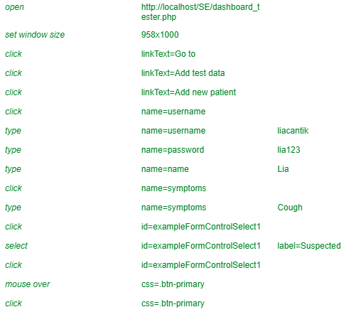

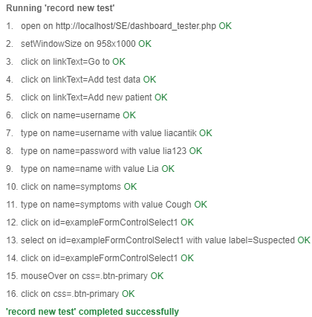

9. Update Test Result

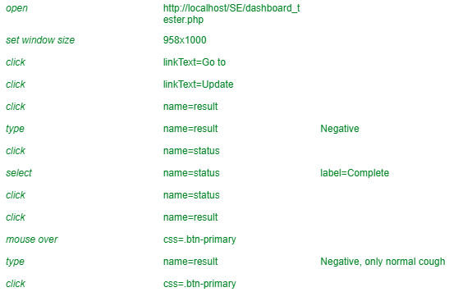

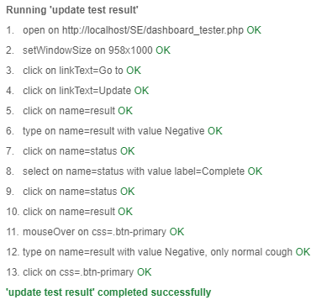

10. View Testing History

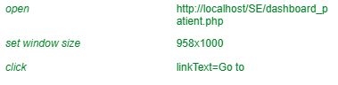

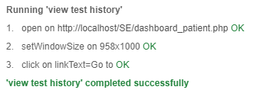

System Testing

Functional Requirements

We will test the system according to the functional requirements.

1. Login

This is the login page that user start first.



This is the Test Centre Manager’s Dashboard.



This is Tester’s Dashboard



2. Logout

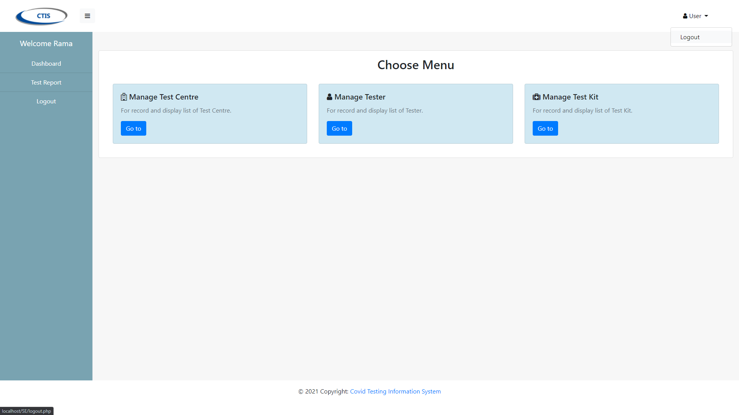

Back to Login page



3. Manage Test Centre

This page displays all the test centre that has been registered.



This page is display form registration of test centre.



4. Record Tester

This page is display list all tester.



This page is display form record for tester.

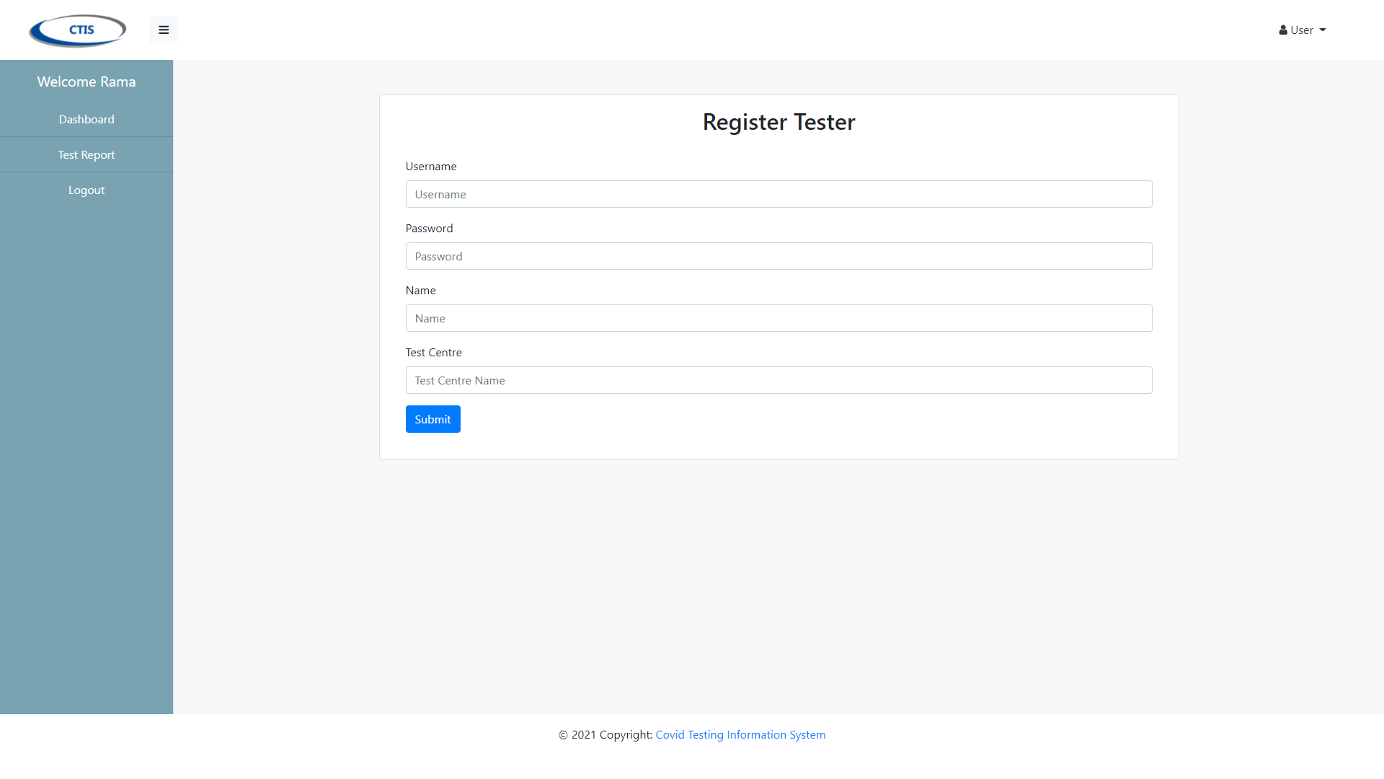

5. Generate Test Report

This page is display list all the test report that has been registered.



6. Manage Test Kit Stock

This page is display list all the test kit that has been registered.



This page is display form record test kit.



This page is display form updated recorded test kit.



7. Record New Test

This page displays all list data patient.



This page is recording new data patient.





8. Update Test Result

This page is update data patient that has been recorded.



9. View Testing History

This page is displaying all result data patient.



Non-functional Requirements

We will test the system according to the non-functional requirements that have been determined previously.

1. Usability: The system must be friendly-use to access for Test Centre Manager, Tester, and Patient.

 



2. Security: using login system for authorization and using hash password for the password.



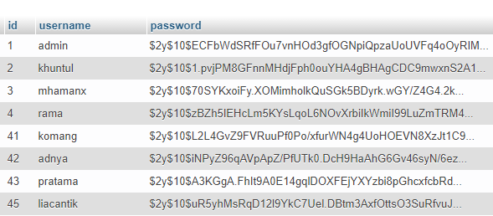

3. Accuracy and Precision: The accuracy of data that has been inputted will stored with its real value.





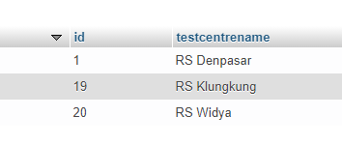

4. Modifiability

This function is for deleted data like Test Data Patient, Tester, Test Centre, and Test Kit Stock.

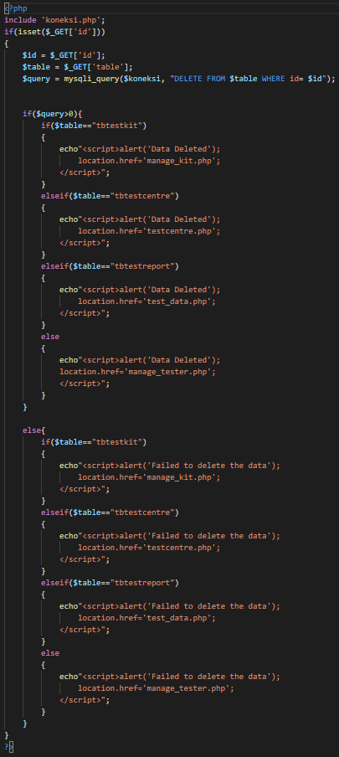

Test Analysis Report

In iteration 2, We managed to make the other use cases that we haven’t made in iteration 1 and repair some bugs in some use cases. After testing the website using unit testing, integration testing, and system testing, we can conclude that the website is able to function properly and It can pass the test. The scope of this testing is to check that the CTIS website is working to the task it assigns. We found bug in login page but we managed to repair it.

Conclusion/Review

This project already meets all the specified conditions. The CTIS that we made has a simple user interface design to make it easier for the user to understand the website. We also put labels with the right word and button with bright color to prevent users from confusing and help them to easier use the website. We are struggling to finish this assignment because we also have another Assignment from the other lectures with deadlines close to each assignment. We made some mistakes when working on this assignment but we learn and try to prevent making the same mistakes again.

Updated Gant Chart

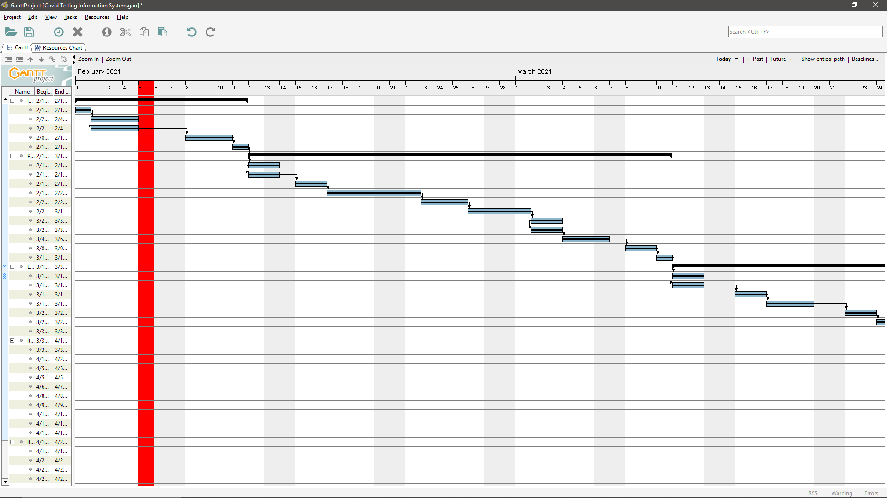

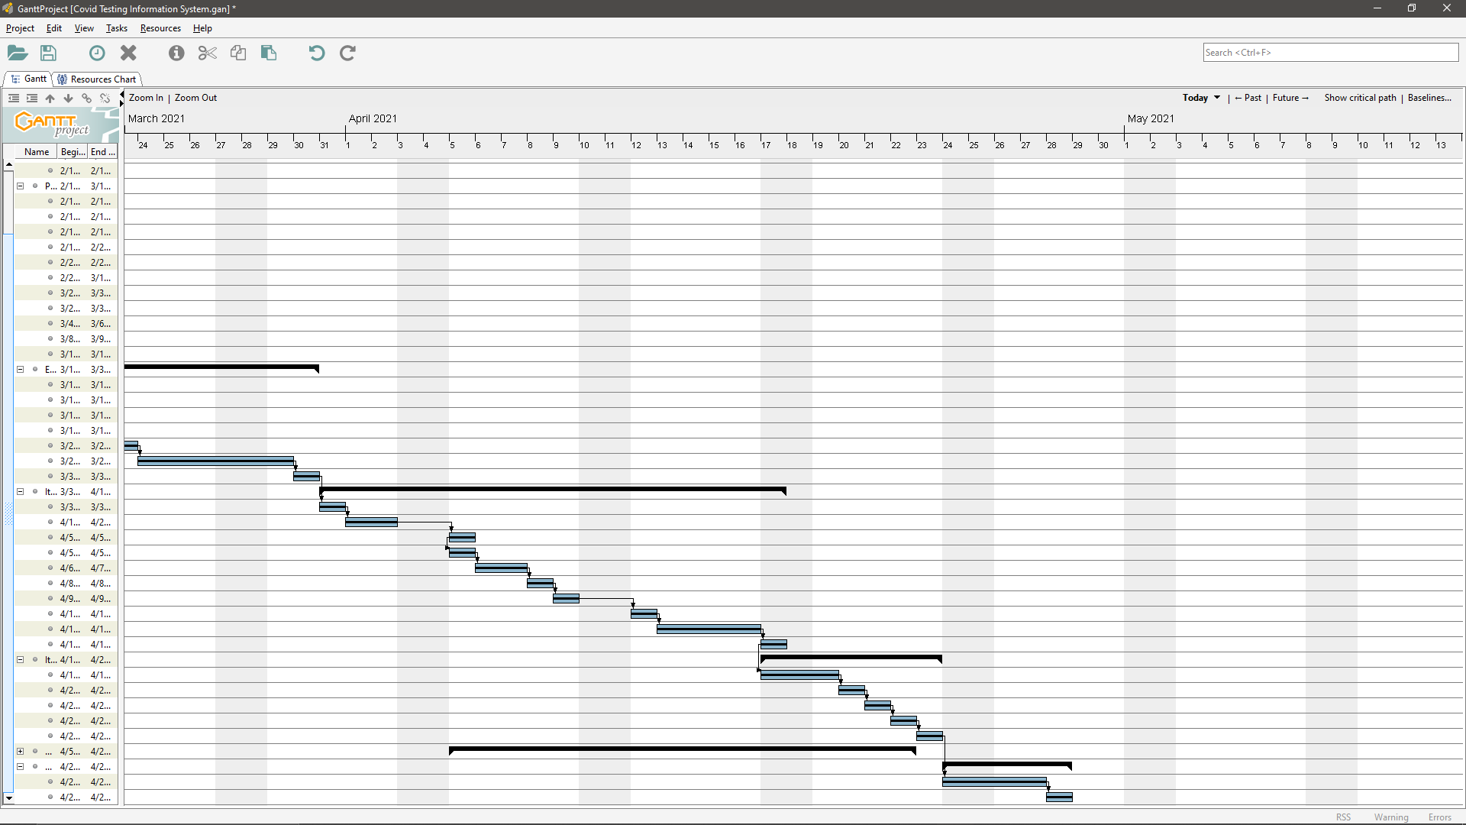

Conclusion/Review (Pande Putu Rama Pratama Putra)

* Did the group meet the objectives defined in Assignment 1?

Yes, we did. We finally meet the objectives in Assignment 1 that create Application with easy-to-use interface and many features that help medical centre to manage patient and the officer as tester in this Pandemic Coronavirus.

* What went wrong and what went right?

We went wrong when we still can manage our time for this assignment and another things-to-do. And also, we went wrong when we cannot manage our teamwork as a team. But we went right when we push our limit for done this assignment as soon as possible with create Applications System with less or no bug found.

* What you would have done differently

Finally, we change our Based Application System. First, we want to use framework for this application but in iteration 1, we met an many bugs in application. So, we change to php programming language to make easier to create.

Conclusion/Review (I Nengah Wahyudi Setiawan)

* Did the group meet the objectives defined in Assignment 1?

Yes, we did.

* What went wrong and what went right?
* What went wrong: we can’t submit the assignment on time, I let my laziness take over my body, there are bug in the website, I just did the assignment 1 day before the deadline, and slow information flow between team mates and team leader because I didn’t reply the team leader chat quickly.
* What went right: we can finish the assignment even though we never meet directly to discuss the project, I can fight my laziness to finish the assignment, and we can work cooperatively.
* What you would have done differently?
* I would make this assignment when I have free time to finish the project and the other assignment to submit it on time.
* I can take over my body from the laziness earlier.
* I can work more cooperative with my team leader to finish this assignment faster.
* I can reply team leader chat faster.